Journal of Analytical Psychology

XVI International Conference
11 - 14 April 2024
University of Essex, Colchester, UK, & ONLINE

CROSSING BORDERS:
Clinical, Theoretical, Cultural and Political Implications
in our Changing World

Co-sponsored by The Society of Analytical Psychology & Essex University
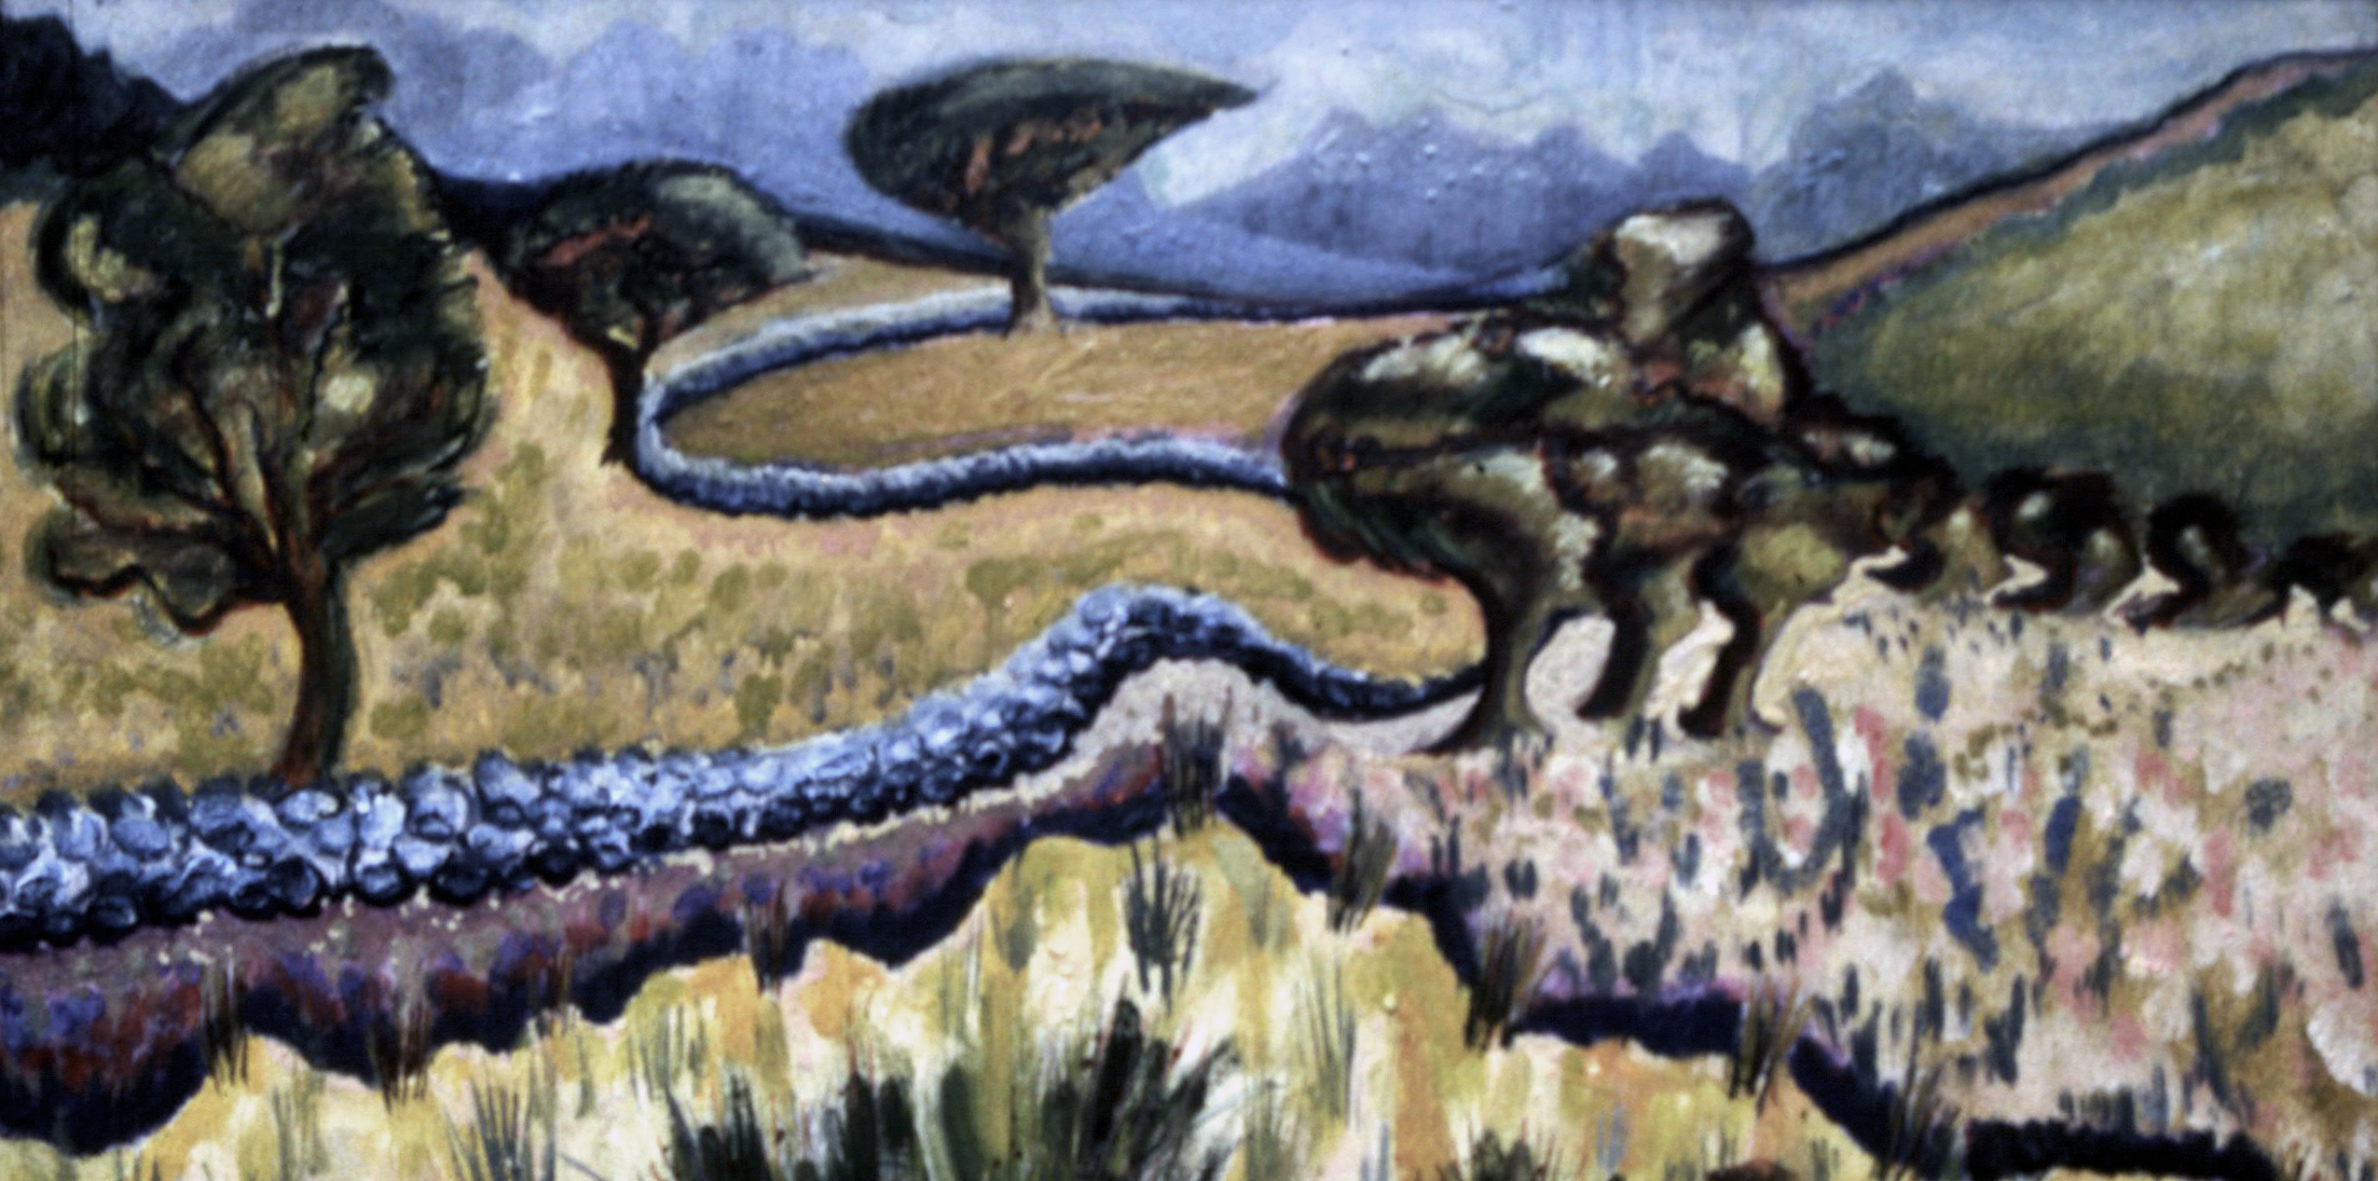
Artist: Lindsey C. Harris

MAIN PROGRAMME
THURSDAY, 11 APRIL

Pre-conference session: Cultural Complexes and Race

9.15am: WELCOME

9.30-11.00 PRESENTATIONS BY EACH FACILITATOR chaired by Amanda Dowd:

Christopher Jerome Carter (US): The Current Role of Analytical Psychology in Maintaining the Fictitious Boundaries Promoted Through the Race Lie, and the Call to Dismantle this Virtual Wall that Exists Through Attitudes of White Supremacy

Elizabeth Brodersen (Germany): The Positioning of Taboo within Cultural Complexes—Theoretical and Clinical Perspectives

Helen Morgan (UK): The Work of Whiteness
11.00 MORNING COFFEE BREAK

11.30-13.00 First workshops
Participants to choose which facilitator’s group they join first.

13.00 LUNCH

14.00-15.30 Second workshops
Participants to join a different second facilitator’s group.

15.30 AFTERNOON TEA

16.00-17.00 Plenary with all facilitators chaired by Amanda Dowd

FRIDAY, 12 APRIL

8.00-9.00 Social dreaming matrix with Ali Zarbafi

Conference Day 1: Borders around Identity: Cultural Expressions of Trauma

9.15am: WELCOME, OPENING ADDRESS AND FIRST PLENARY SPEAKER chaired by Ann Addison

9.30-9.45 Renos Papadopoulos (UK): Opening Address (via Zoom)

9.45-10.45 Monica Luci (UK/IT): Disputed Boundaries of the Self, the Group, and their Environment: What we Learn from Refugees about Trauma, War and Culture

10.45 MORNING COFFEE

11.15 SECOND PLENARY SPEAKER chaired by Ann Addison

11.15-12.15 Karin Fleischer (Argentina): Stolen Identities, Suspended Lives: Embodied Analysis with Victims of Early Trauma Due to State Terrorism

12.15 LUNCH

13.30-15.00 Breakout panels 1a, 1b, 1c – see table at end of document

15.00 TEA

15.30-17.00 Breakout panels 2a, 2b, 2c – see table at end of document

SHORT BREAK

THIRD PLENARY SPEAKER chaired by Arthur Niesser

17.30-18.15 Andrew Samuels: On Analytical Psychology and Politics: A Cutting Edge and Transformative Contribution—OR A Narcissistic Total Waste of Time Only of Interest to Some Analysts and Therapists?

18.30 FRIDAY EVENING: DRINKS RECEPTION

SATURDAY, 13 APRIL

8.00-9.00 Social dreaming matrix with Ali Zarbafi

Conference Day 2: Borders around Identity: Gender Fluidity: Self in Culture

9.45am: WELCOME AND FIRST PLENARY SPEAKER chaired by John Merchant

10.00-11.00 Robert Tyminski (US): Humanizing Different Archetypal Expressions of Gender Expansiveness

11.00 MORNING COFFEE

SECOND PLENARY SPEAKER chaired by John Merchant

11.30-12.30 Jay Barlow (UK): Engendering Identity when Boundaries Confirm an Exiled Self
12.30 LUNCH

13.30-15.00 Breakout panels 1a, 1b, 1c – see table at end of document

15.00 AFTERNOON TEA

15.30-17.00 Breakout panels 2a, 2b, 2c – see table at end of document

SATURDAY NIGHT: CONFERENCE GALA DINNER
(Coach at 6.30 for 6.45 departure; drinks until 7.45; dinner from 7.45)

SUNDAY, 14 APRIL

8.00-9.00 Social dreaming matrix with Ali Zarbafi

Conference Day 3: Borders around Identity: Working Within and Across Different Faiths

CONVENE 9.45AM: WELCOME AND FIRST PLENARY SPEAKER chaired by Carolyn Bates

10.00-11.00 Les Stein (US/AU): The Unifying Self in all Faiths and Beliefs

11.00 MORNING COFFEE

SECOND PLENARY SPEAKER chaired by Carolyn Bates

11.30-12.30 Murray Stein (US/CH): The Faithless Analyst (via Zoom)

12.30 SHORT BREAK

PLENARY chaired by Arthur Niesser

12.45-13.45 Closing Conference Plenary

BOOKING INFORMATION
Registration link:
https://www.essex.ac.uk/events/2024/04/11/journal-of-analytical-psychology-international-conference-2024

Accommodation link:
https://thejap.org/conferences/essex-2024-accommodation

Travel link:
https://www.essex.ac.uk/visit-us/plan-your-visit/travel-to-colchester

Colchester tourist info and images:
https://www.visitcolchester.com/things-to-do

We hope to see you at what promises to be a rich, engaging and challenging four days!

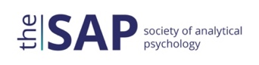

BREAKOUT PROGRAMME

FRIDAY 12 APRIL, BREAKOUT SESSION 1: 13.30-15.00

Time | Breakout Room 1 | Breakout Room 2 | Breakout Room 3
13.30 -14.00 | SUSAN SCHWARTZ  The Analytical Bridge to Self through Cultural Diversity  (45 mins – 13.30-14.15)  ---------------------------------  STEVE MYERS  The Public Understanding of Analytical Psychology  (45 mins – 14.15-15.00) | STEPHAN ALDER  Intercommunication Against Fear—Crossing Borders or Creating a Holding Frame—Group Analytical Understanding Includes Verbatim Protocols | VICENTE L. DE MOURA  The Process of Infantilization—Psychological Patterns After Crossing Borders  (45 mins – 13.30-14.15)  ------------------------------------  PHYLLIS JENSEN  The Archetype of Migration as a Heroic Journey  (45 mins – 14.15-15.00)  (Via Zoom)
14.00 -14.30 |  | ELANA LAKH  When our Shadow Makes us Blind and Deaf to Suffering: The Power of a Cultural Complex
14.30 -15.00 |  | HUGO MORAES  Borderless Odyssey: War, PTSD, Fire and Reparation

FRIDAY 12 APRIL, BREAKOUT SESSION 2: 15.30-17.00

Time | Breakout Room 1 | Breakout Room 2 | Breakout Room 3
15.30 -16.00 | CHRISTIAN ROESLER, SARAH HALL &  URSULA BRASCH  Panel on dream research:  1. ROESLER: How Dreams are Related to the Course of Therapy  (Via Zoom)  2. HALL: Dreamcovery: A Jungian Analysis of the Meaning and Clinical Significance of Drug-Dreams  3. BRASCH: Cultural Differences in Dream Ego Agency—An Analysis of Chinese Dreams  (Via Zoom  (1½ hours – 15.30-17.00) | JOLANTA KOWAL & EWA WINKLER  Crossing Borders—A Research Report on the Work of Jungian Psycho-therapists in the Face of Contemporary Challenges. How To Be a Jungian in 2025? | HSIANG-JU HO  Utilizing AI for Dream Content Analysis: A Case Study of Serial Dreams of a Taiwanese Adult Woman Who Witnessed Domestic Violence in Childhood
16.00 -16.30 |  | CLARE SIMMONDS  Turning our Gaze Inwards: A Socio-Analysis of the Psychoanalytic Field | MALCOLM RUSHTON  The Borderland Between Analysis and Shamanism. A Deepening of Unconscious Connectivity and Alchemical Process in Analysis
16.30 -17.00 |  | RACHEL DUNKLEY JONES & TOM DUNKLEY JONES  Our Troubled Climate: A Dialogue Between Psyche and Science | WEI (DAVID) ZHANG  What Does the Dream Say? Exploring Chinese Cultural Archetypes and Model of Depth Working

SATURDAY 13 APRIL, BREAKOUT SESSION 1: 13.30-15.00

Time | Breakout Room 1 | Breakout Room 2 | Breakout Room 3
13.30 -14.00 | MARK SABAN  Dissolving the Psychological Subject: Inside and Outside the Therapeutic Bond  (45 mins – 13.30-14.15)  -----------------------------------  NORA SWAN-FOSTER  Rekindling the Indigenous Psyche Through Dream Work  (Via Zoom)  (45 mins – 14.15-15.00) | GINNY HILL  “My constant companion”: Jung’s Commentary on The Tibetan Book of the Dead | PABLO DE ASSIS  Decolonizing Clinical Psychology: A Jungian Perspective  (Via Zoom)
14.00 -14.30 |  | AUREA AFONSO CAETANO & TERESA MACHADO  Estamira: An Experience in Border Crossing  (Via Zoom) | MARTINA BOTTAZZO  “Crossing Borders” Out of a High Demand Religious Group  (Via Zoom)
14.30 -15.00 |  | SULAGNA SENGUPTA  The Hybrid Self: Cultural Crossings and New Formations | JOHN PELLITTERI  An Emotional Intelligence Perspective on Analytical Psychology

SATURDAY 13 APRIL, BREAKOUT SESSION 2: 15.30-17.00

Time | Breakout Room 1 | Breakout Room 2 | Breakout Room 3
15.30 -16.00 | EGIDIJA SEPUTYTE  We Make Robots Behave. Do We? Complex Interrelatedness of the Archetypal and the Instinctual in Meeting the Other as AI  (45 mins – 15.30-16.15)  -----------------------------------  RODERICK MAIN  Border Crossings in the Interdisciplinary Collaboration of Jung and Pauli  (45 mins – 16.15-17.00) | EDUARDO VIEZCA  Decolonial Feminism & Transfeminist Psychology: Can “US Women of Colour Critique” Support Analytical Psychology? | ROLANDO J. FUENTES  A Part Of and Apart From: Living and Working in Between Cultural Borders
16.00 -16.30 |  | CHARLES G. ZIMBRICK-ROGERS  Post-Apocalyptic Bodies: Toward a Dionysian Mode of Gender and Embodiment | XIAO YOU  Cross-Cultural Supervision in China: Current Status, Issues and Directions for Development
16.30 -17.00 |  | NATALIA SEREBRENNIKOVA  Breaking Through for a Generative New: Transgressions in Analytical Practice | JINGCHAO ZENG  The I Ching: Crossing the Borders Between Jungian Psychology and Chinese Culture

